13 Reasons why we encourage others to join Max International Now
URGENT
You really must see this!



A Fantastic Day To You!

This is a lengthy message that needs to be digested S-L-O-W-L-Y!

If you don't have time to digest all 13 Points now, please come back later.

From a global leader in the network marketing industry:

"Ever since I joined the Shaklee Corporation 30 years ago at the age of 28, I have continued to keep my ear to the ground for Break-Through nutritional products that promote Health, Wellness and Longevity. After all, I am in that infamous "Baby Boomer" generation that is, supposedly, spending billions on living longer...

... 5 weeks ago, my wife asked me to accompany her to Salt Lake City to meet the company's Owners, Founders, and Senior Management. We were so impressed with what we saw and heard there, that we went back to Salt Lake City again 4 weeks later and took a bunch of people with us." ~ R.S.

Here are the first 13 Reasons why we encourage you to join Max International:

1. Breakthrough Products:

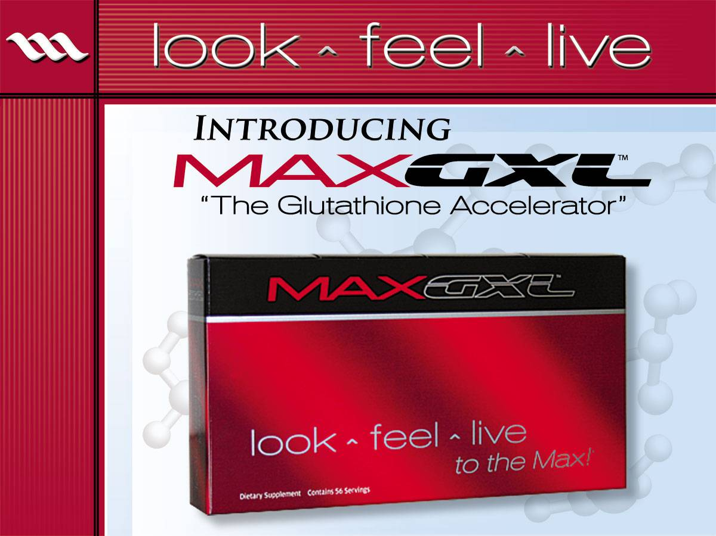

When Steve Scott talks about the mission of the company and the dedication to the values of helping others, you can hear the commitment in his energy!

Our first product, MaxGXL, is the ONLY product in the world that is clinically proven to increase Glutathione levels in every cell in the body up to 400%, as well as recycle the used glutathione that is stored in the liver.

Steve told us that Max will never be a catalog company. We will only represent
"Breakthrough" products. Here is how Steve described a Breakthrough product:
- When Steve was in the infomercial business his company researched 1,000 products to find one "Breakthrough" product good enough to turn into an infomercial.
- Guthy-Renker evaluates 2,000 products to find one for an infomercial.
- Home Shopping Network asked Steve's company to evaluate their products for a year and choose which ones were good enough to do an infomercial on. At the end of one year they had not found one product that was what Steve called a "Breakthrough" product.
- In addition to the incredible MaxGXL Breakthrough product, Max International has 3 more Breakthrough products coming out in the near future:
A. Weight Loss Break-through supplement that, in clinical trials resulted in the average woman losing 22 lbs of fat and gained 1-1/2 lbs of muscle in 8 weeks.
B. Life Extension Break-through product containing enzymes that, when given to mice, lengthen their life-span from 30-50%.
C. Skin Care Break-through product - Scientists at Clemson University have reduced glutathione to nano-size and when put into skin cream, results are visible in 90 seconds.
2. Dr. Robert Keller

Researcher, Scientist, Clinical Doctor, and Creator of the Compositionally Patented breakthrough product, MaxGXL
Dr. Robert Keller was voted one of America's top Physicians for the past 5 years and is on the Board of Governors of the American Academy of HIV Medicine, as well as being recognized as one of the top 2,000 scientists of the 21st century. Dr. Keller treats people with Aids, Cancer, Chronic Fatigue Syndrome, and Auto-Immune disorders in his Florida clinic. In an effort to help his patients, Dr. Keller created/formulated and has been using MaxGXL in his practice (and also in Africa) for over 10 years with much success.

Therefore, although Max International is only 1 year old, the product has been undergoing various versions, clinical trials, and testing for more than 10 years.

3. Composition Patent:

There are two types of patents awarded to nutritional products. The U.S. Patent office awarded Dr. Keller a "Composition Patent" for his scientific discovery. Actually, as of this writing, Dr. Keller has been awarded 3 compositional patents. He is also doing a Phase II study in Africa that is doing clinical testing for a patented drug Dr. Keller developed to deal with HIV/Aids and Malaria.

1. UTILITY PATENT - This patent allows for a competitor to change up to 30% of the formulation and still receive a patent on a similar product.

2. COMPOSITION PATENT - This patent does not allow anyone to change even one single ingredient in an attempt to duplicate your product. This is the same patent that is usually reserved for pharmaceutical companies.

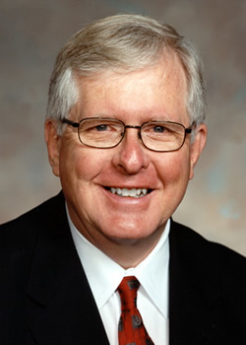
4. Dr. John C. Nelson:

Dr. John C. Nelson, the immediate past President of the American Medical Association, a man who was passionate about putting what he called "quack" products out of business while president of the AMA, said this about MaxGXL:

"This product, in my opinion, represents the single most important breakthrough in health that I will witness in my lifetime. I believe it will revolutionize, change, and transform the practice of medicine worldwide and make Dr. Robert Keller more famous than Jonas Salk who created the polio vaccine."

5. Superior to Juices, Pills, Berries, Bark, Plants and Magical Mystery Potions from Madagascar!

There are 2 way to repair Free Radical damage on the cellular level
- Exogenous - Plant source Pills and Juices repair "SOME" free radical damage from the outside in by stimulating regeneration.
- Endogenous (MaxGXL) - Created naturally within all the trillions of cells and repairs "ALL" free radical damage from the inside out by initiating regeneration
This is a Very BIG Deal!
For those who understand how Free Radicals "Steal" electrons from other cells...

- Vitamin E has......... 3 extra electrons to share
- Vitamin C has......... 5 extra electrons to share
- OPC's have.............. 250 extra electrons to share
- Glutathione has...... 1 million plus extra electrons to share

Our Body’s Glutathione is the Master Antioxidant!

6. 8 things to look for when evaluating a
Network Marketing company

Rick Teague, a team leader and double-degreed lawyer, listed 8 things to look for when evaluating a Network Marketing company. When he considered moving to Max International, he gave all 8 categories an A+...

# | Category | Grade | Assessment Notes on Max International
1 | OWNERSHIP | A+ | Successful and credible track record; well financed
2 | LEADERSHIP | A+ | Management team experienced in building and guiding an international company
3 | PRODUCTS | A+ | Only breakthrough/unique products, science backed, it works for consumers as claimed
4 | SALES TOOLS | A+ | Attractive, friendly, functional, and priced fairly
5 | TECHNOLOGY | A+ | Latest and best
6 | TRENDS | A+ | Home-based business, wellness industry booming
7 | ECONOMY | A+ | People looking for extra income or starting their own business with low start up costs; provides cushion for transition from corporate jobs
8 | TIMING | A+ | 'Baby Boomers' spending trillions on age management and wellness products
Click here to view the Max Purpose and Credo

7. Steve Scott:
(co-founder/co-owner)

Founder, Steve Scott, was the creator of the Television Infomercial business over 30 years
ago. Steve has produced infomercials with over 91 Hollywood Movie Stars such as Chuck
Norris & Christie Brinkley (Total Gym), Richard Simmons (Sweatin' to the Oldies), John
Tesh & Connie Sellica (Gary Smalley Marriage Enrichment Course) and many others.
Steve also started 10 other businesses that all grew into multi-million dollar companies.

When Steve was asked to market MaxGXL, his original reaction was, "No, I do not promote
products that go into the mouth". To make a long story short - when Steve saw the
Scientific evidence that MaxGXL did, in fact, slow down the aging process and eliminate
many age related diseases, he told his partners that he was going to retire from doing
infomercials and spend the rest of his life marketing this Breakthrough product.

Click to view "Steve Scott’s Vision" & other videos
Watch Steve's Interview on Larry King >>> www.stevenkscott.com

8. Guthy-Renker
(co-owners):

When Steve Scott realized the magnitude of this Breakthrough product, he asked his
friends and competitors, Bill Guthy and Greg Renker to join him. Guthy-Renker had a
team of Scientists and Doctors evaluate the product and, 2 weeks later, came back to them
saying, "This is the real deal"... MaxGXL is scientifically PROVEN to slow down aging
and eliminate many age related diseases. Guthy-Renker eagerly became part owners of
Max International and committed to produce infomercials with Hollywood movie stars
on each of Max's products.

Did you get that? Infomercials on Max's Products to make them a household word

Launched 20 years ago by Co-CEOs Bill Guthy and Greg Renker, Guthy-Renker is today
one of the world's largest direct response television companies with sales of more than $1.5
Billion per year and an average annual growth rate of 25% over the last 10 years.

http://www.guthy-renker.com/ >>>

9. Greg Fullerton
(co-owner):

Those of you who have been in the sales industry are probably familiar with "Franklin
Covey" (Franklin Planner). Greg Fullerton was the founder/creator of Franklin Quest
which later merged with Steven Covey (7 Habits of Highly Successful People) to form
Franklin Covey. Greg Fullerton has given his time management seminars to ALL 500 of
the Fortune 500 Companies.

When Steve Scott introduced Greg to MaxGXL and when Greg saw how it was effecting the
quality of people's lives, he jumped in with both feet and made a commitment to spend the
rest of his life building Max International.

See the brief bios and hear a few words from all the co-founders >>>

10. Salt Lake City:

For some reason, Salt Lake City is the home of 70 plus major Network Marketing
companies. Since neither Greg Fullerton nor Steve Scott nor Bill Guthy nor Greg
Renker had any experience building a network marketing business, they used their
financial resources to recruit some of the most qualified and most experienced
individuals in the entire industry from these other companies.

For example, many of our V.P.'s have either been the President, Owner or Founder of their
own Network Marketing company somewhere along the way. These well qualified leaders
are the Best of the Best and more than capable of taking Max International worldwide...
because they have all done it before.

Read about the Max Management Team >>>

11. Deep Pockets:

It is evident by the quality of Leadership recruited from these other companies and... the
quality of the Max Marketing materials, that there is plenty of money behind this
company. Every month they fly over 100 Network Marketers into the home office... pick
them up in limos, pay for their hotel stay for 2 - 3 nights and wine and dine them with great food.

During these 48-hour stays, the co-founders, owners and top level management mingle with their guests, treat everyone with respect and make themselves accessible to each and every
person there. They share their heart and their dream, answer questions and invite their
guests to join them in building a championship company.

(To qualify for the next fly-in ... anyone who has earned $5,000/month in a
network marketing company sometime in the past 3 years can go all expenses paid. Those
who do not meet those qualifications can pay their own [transportation] but everything else is paid by the company when you arrive.)

Think about this - Perhaps you don't qualify for Free Airfare but you know someone
who does. Get me on the phone with that individual. Last person who did this took 3
more people with them to the Fly-In. All 4 of them joined under that individual.

While Steve Scott was speaking he mistakenly let his net worth slip out... I nearly fell off
my chair. He also let it slip that while in the infomercial business, he was earning $600,000
per month. Steve produced infomercials for 30 years. On a positive note... Steve is one
of the most humble men I have ever met. He openly gave God credit for every success he
ever accomplished in life and refused to take any credit himself. Meeting Steve was the
highlight of my visit to Salt Lake City.

12. Compensation Plan:

The Max Compensation Plan is powerful and unique "Hybrid" of Binary combined with a
Uni-level that has unlimited income potential. This combination is attracting many
Legendary, Professional Network Marketers who are jumping on board NOW while the
company is young.

REMEMBER - In Binary, those who are positioned at the top receive lots of people placed
under them. URGENT - Our Binary is just getting started and we plan to place 30 - 40
more people on each leg in the next couple of months. They will each sponsor a couple of
people... who will sponsor a couple of people... all the way to China.

TIMING IS EVERYTHING

Max pays you $20/month on every customer who is not a sales rep.. It costs ZERO to sign
up as a Customer (just a $66 monthly auto-ship). One Doctor (Gynecologist), who has 200
of his patients on auto-ship, earns over $4,000/month from Max, just on customer orders.

More Max Opportunity and Comp Plan Info >>>

13. Customer to Rep Ratio:

Between 35 - 40% of our monthly business comes from "Customers" who are not signed up as Reps. This amazes me... and proves the company is Product Driven.

This Is Unheard of in Our Industry... The Product Flat Out WORKS!

We greatly look forward to being your guide as you explore this remarkable product and company. Please don’t hesitate to be in touch if we can help in any way.

Here's What You Need To Do Next...

1. CALL the person who shared this information with you now, so he or she can answer your questions and strategically position you in the genealogy.

2. Visit the Max website >>> http://www.maxgxl.com/gxlglobal >>> and watch all 5 Videos in the "Max Video" Link located at the top right of the front page.
---------------------------------------------------------------
Are you living outside the US or Canada?

P.S. Max International's officially launched Canada in May 2008 and are about 90 days away from launching in Australia, NZ, and Philippines… with Japan and Indonesia not far behind! This is going to be HUGE!

Interested Marketers and others outside the US and Canada, who wish to reserve your place and recruit now, be sure contact us now, before trying to sign up. We will share a specific strategy for you and your region if it is appropriate for you to be involved at this time.

Network Marketing professionals who have helped to develop and open countries’ markets may apply for getting of the list to open your region. For those who qualify, we can forward the preliminary business development assessment package for you to submit.

Look ~ Feel ~ Live …to the Max!

